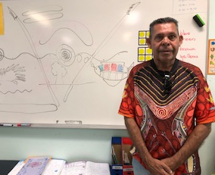
Welcome Elliot
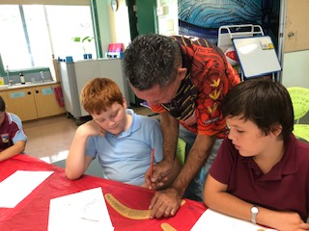
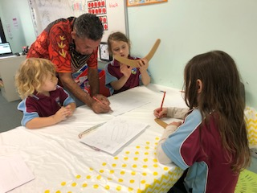
NEWSLETTER

TERM 1 – WEEK 4
UPCOMING EVENTS
Thurs 20th Feb @ 5pm
Parent Information Session
Tues 25th Feb @ 9am
Pancake Day
Tues 10th March
Interrelate @ Blakebrook (Yr 5&6) Private transport

11th & 12th March
Wendy at Leadership Conference in Sydney
Thurs 9th April
Last day of Term 1 2020
Larnook School would like to welcome Elliot Knight. Elliot will be joining us every Wednesday to work with the students and share his history, language & culture with the the students and staff.

The students thoroughly enjoyed listening to and talking with Elliot on Wednesday. Elliot spoke about his culture and reinforced the respect we should all show to each other. He taught students some Bundjalung language and did some amazing dot paintings with K-6.
Parent Online Payments (POP)

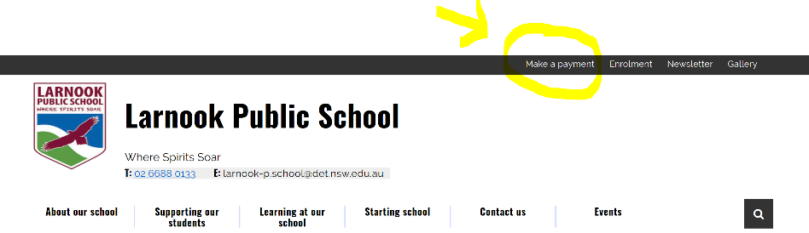
Please remember that payments to the school can be made online. To access this you go to the school website and click on the ‘make a payment’ tab on the top right hand side of the web page.

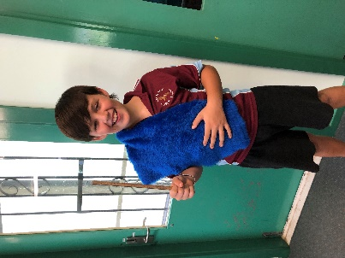

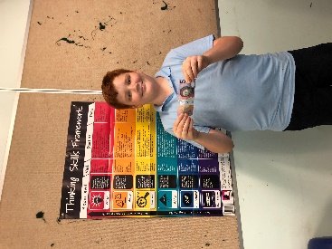

SRC Election

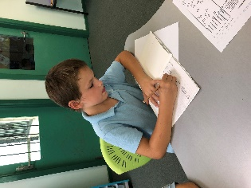
In Week 2 contenders for positions on the Larnook Public School Student Representative Council (SRC), presented speeches to their peers. An election for positions was held with the following results: Charlie Mullenberg ~ President, Sonic Jones ~ Treasurer and Marshall Mullenberg ~ Secretary. The SRC is an important aspect of the school as it presents a forum where students can ‘have their say’ about things that matter to them. They also gain responsibilities, leadership skills and have the opportunity to experience many ‘real life’ situations, eg: chairing meetings, budgeting, planning etc. Already the SRC has had their first meeting and discussed some exciting new ideas for this year. ‘Watch This Space’ for upcoming events created or sponsored by the SRC. Congratulations Charlie, Sonic and Marshall.

Lindy Treasure :)

During Week 3 the school had an Audit by the Department. There were a few minor things brought to my attention from this and one of them was in regard to parent and carers advising the school of their child’s absences.
If your child is away from school, we need to be advised via a phone call, email or note explaining their absence. If they are leaving early or arriving late to school, they also need to be signed in or out at the office.
I would appreciate your assistance in rectifying this in the future. Thank you.

The swimming Carnival that was scheduled for last Friday 14th Feb was postponed due to the bad weather. It is now scheduled for tomorrow Tuesday 18th February. All other details remain the same – Lismore Pool, parent transport, events commence at ????? and conclude at ????

Good to go: most drink bottles and cans
As a part of fundraising for the school we have a return and earn bin at the front of the school. All funds raised from this during semester 1 will go to helping fund the senior students going to Canberra in July. Get behind them and start depositing your cans, bottles and cartons in the bin provided.
These containers are most commonly found as litter in NSW. They’re often consumed ‘on the go.’
- Cans (e.g. soft drinks)
- Bottles ( e.g. beer bottles)
- Cartons (e.g. milk cartons)
- Juice boxes or poppers
Most containers between 150ml and 3 litres are accepted and can get you a refund. However, they must…
- Be in good condition (not be crushed or broken)
- Be empty
- Have the label attached

2
3

4

