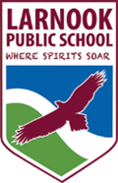
Newsletter
Term 3 | Week 8 | Larnook Public School
Announcements  Congratulations to Sherrell for a much deserved award during Education Week. Sherrell contributes so much to the school and it was wonderful to have this officially acknowledged at the award ceremony at Lismore Workers Club.  A reminder that school fees are now due. School fees go directly to support your child’s learning at the school as well as reducing the cost of excursions. School fees are $40 per child or $80 per family. These can be paid directly to the office or via the online payment system accessed via our web page. Wendy Emerton |  | Important Dates  Week 8  Wednesday 11th September - Swimming  Thursday 12th September – P&C Meeting 1pm  Week 9  Thursday 19th September – ½ day holiday  Sat 21st Sept – Hanging Rock Hall’s Got Talent  Week 10  Friday 27th September – Last day of term  Term 4  14th October – Students return to school  18th October – Lismore Show
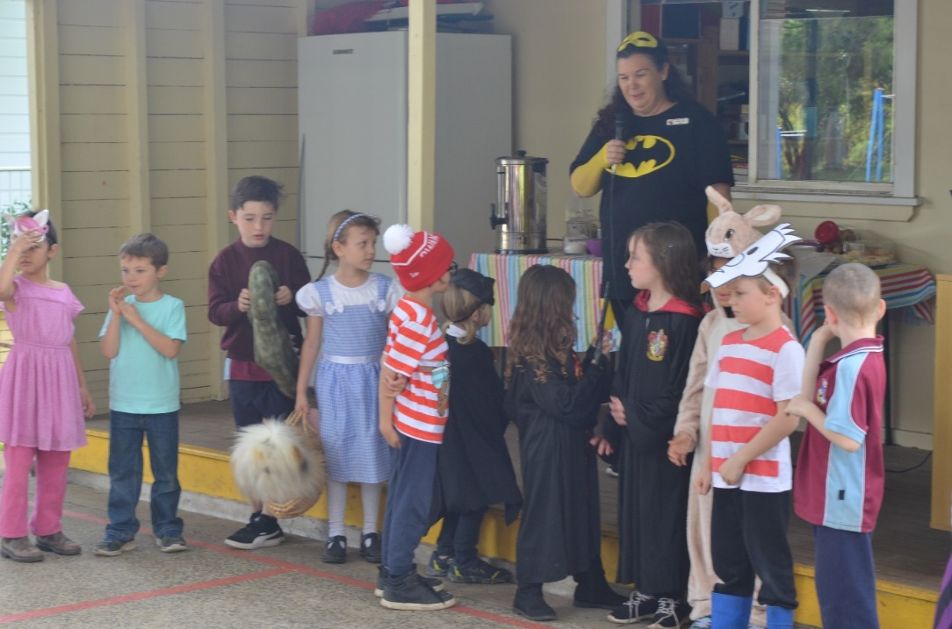
Book Week & Fair Update
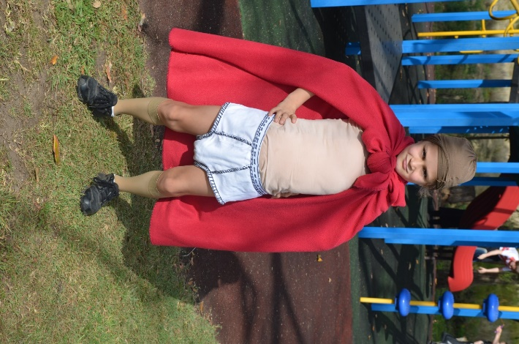
​What an exciting and fun time it is dressing up for book week, everyone looked super! Congratulations to those who won a book voucher and prize for their efforts with amazing costumes. It was lovely to see some parents and carers come along to watch the Book Week parade and stay for morning tea. Thank you for purchasing items from the Book Fair, our sales reach a record $845.00 and now we will have quite a few dollars to spend on new books for the Library. Also a big thanks to Gaye for donating two new non-fiction books to the Library, the children will enjoy these books.

WANTED HOUSE TO RENT
Local family looking for a pet friendly house to rent. If you have or know of any properties that are available please contact the school so we can pass on the details. Thank you.

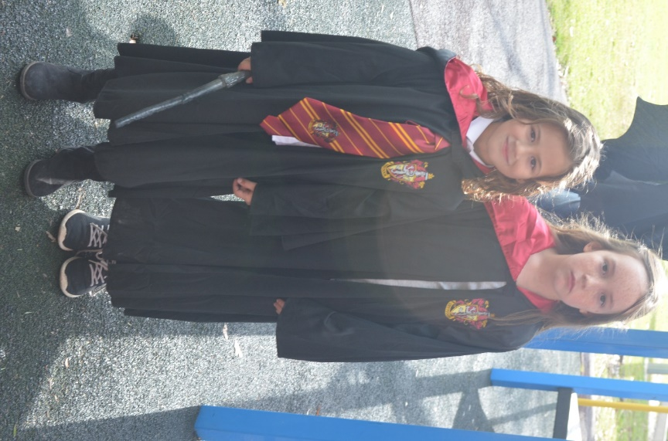
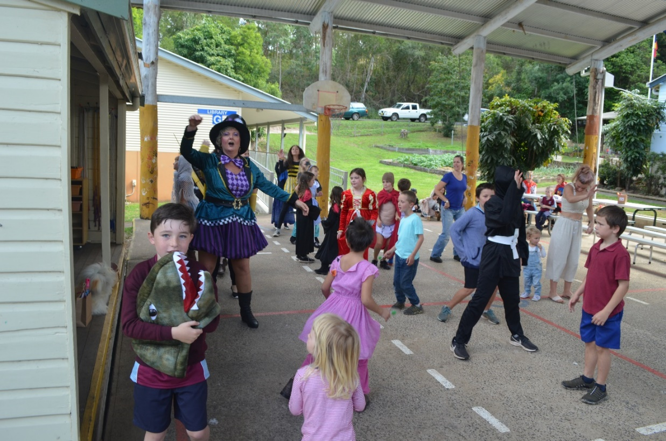
BOOK FAIR FUN!
