Newsletter
Term 3 | Week 10 | Larnook Public School
Announcements  As we near the end of Term 3 I reflect on the amazing things that have occurred across the school – Brisbane excursion, Byron Bay excursion, Athletics carnival, Bike month, Recycle education, Officer Presgrave safety talk, Wild Rangers visit, Book Week Celebrations, School Photos, public speaking, garden judging, naplan results, Hanging Rocks Got Talent fundraising and the commencement of the school’s front boundary fence, combined with lots of fun classroom learning. I would like to thank everyone that has assisted us to make this term an amazing one. Thank you. Wendy  . |  | Important Dates  Week 10  26th Sept – School Canteen  27th Sept – School Disco (PBL reward)  Term 4  Week 1  14th Oct – School resumes  18th Oct – Lismore Show  Week 4  7th Nov – Kindy Orientation commences  Week 7  27th Nov – Celebration evening  Week 10  16th to 18th Dec – Intensive swimming at Trinity

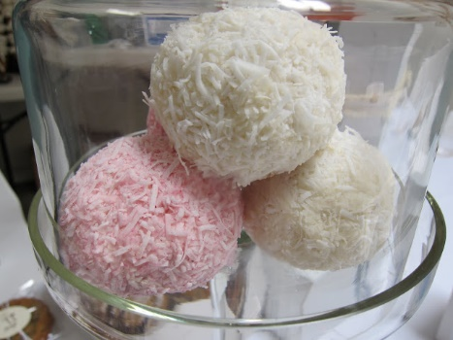
Special Canteen

Thursday 26 September
Tasty Veg and Egg Muffins with Salad
Coconut Snowball Delight

Cost for meal deal is $4.00 per serve

Please return orders to Gaye by Wednesday 25th September.

Thank you.

PBL Celebration Disco Last Day of Term 3
School Disco will commence at 1pm through until 3pm.
School will provide Pizzas.

Students please come dressed in your party clothes.
Jiggi Public Speaking
Congratulations to the Ali’i, Quinn, Zac and Jada for braving the nerves and speaking so well on the day.

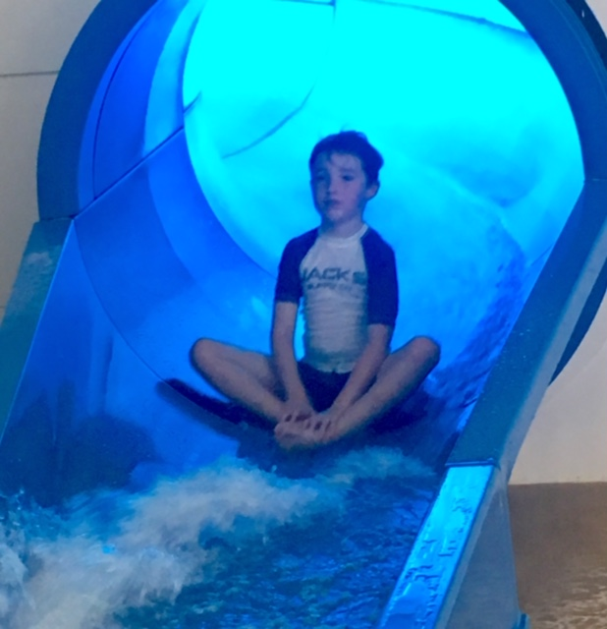
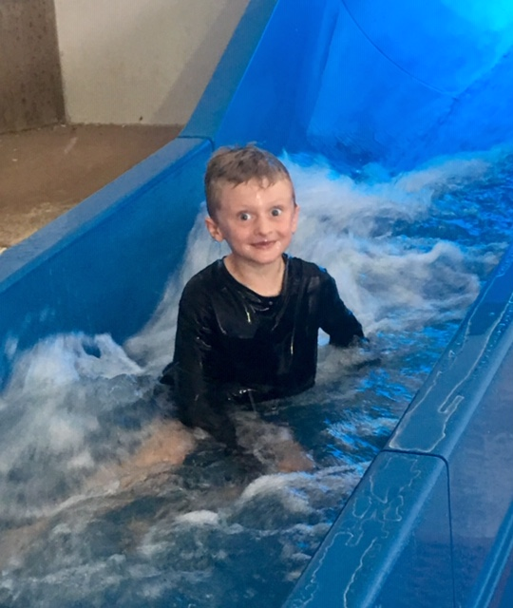
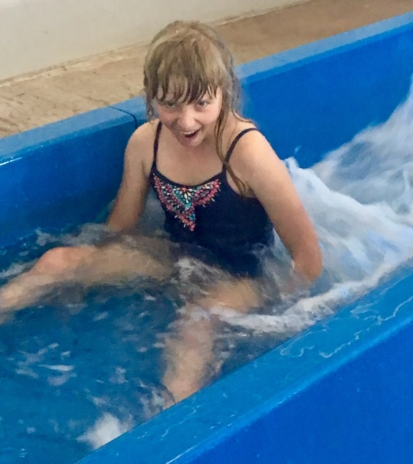
Some of our happy swimming faces

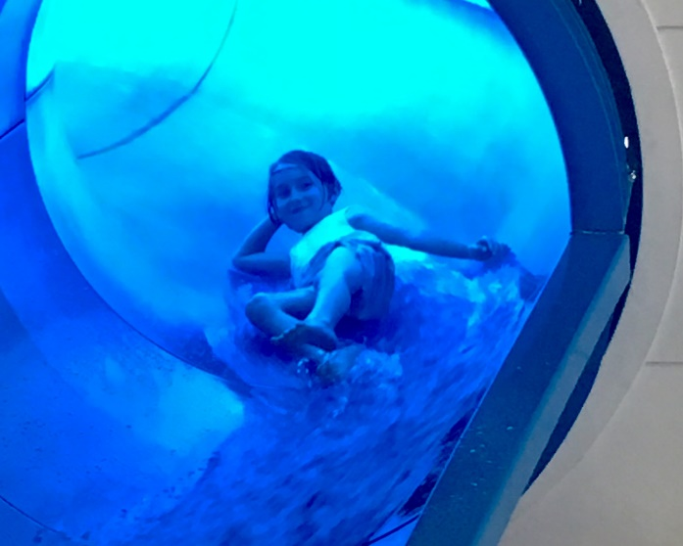

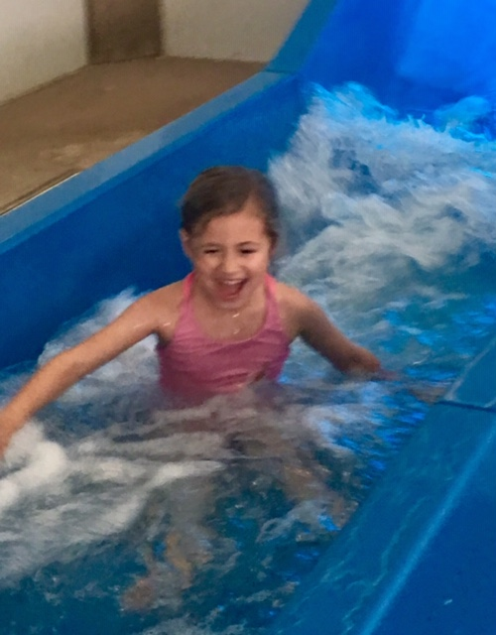

School Garden Judging
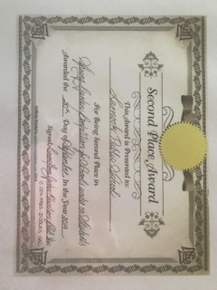
Congratulations to our gardeners and helpers. We achieved second place and they commended us on the amount of work we had achieved over the past twelve months.

